Nguyễn Thụy Vy – 13521064

This program is developed on Visual Studio 2013 Ultimate.

**Program startup**

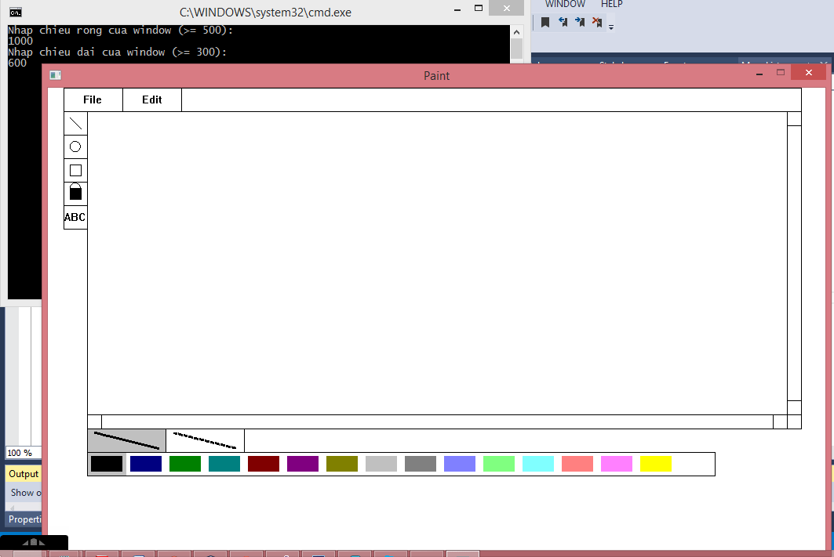

Width and height of the program can be customed by typing them through console. The minimum width is 500 and the minimum height is 300.

**Color selection**

E:\Paint-2.png

Remember to select the color before drawing or filling color. There are 16 colors for you to choose.

**Line drawing**

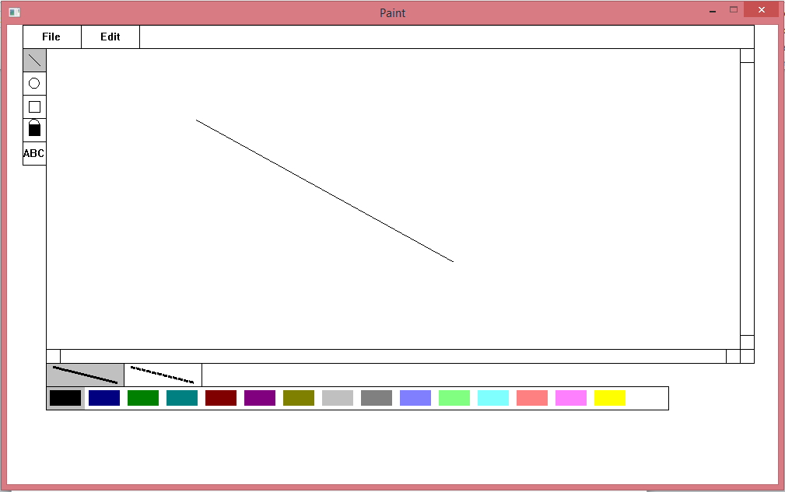

Select the E:\Paint-4.pngbutton on tool panel then choose the first point through left click on the drawing area. While keeping left click, you may drag the line all the way until you are content then you release the left click. If you were not careful enough that you release the left click outside program window, you are still able to hover the mouse back to the program window and then have a left click event replacing missing release left click event.

**Circle drawing**

* **By mouse**

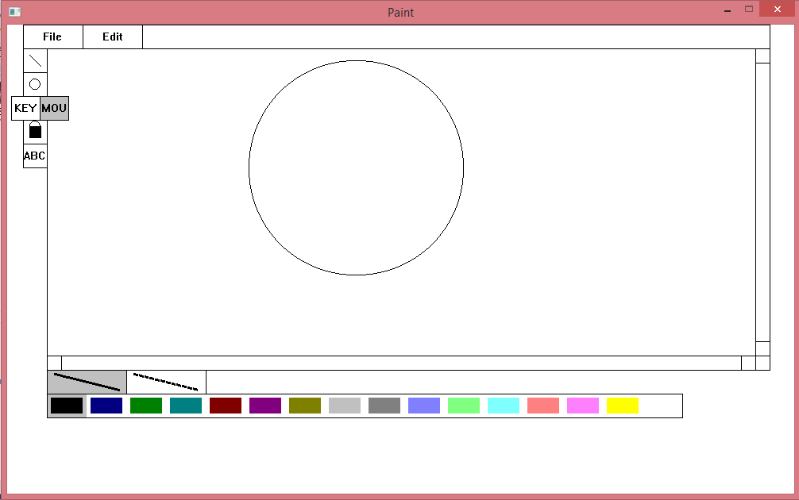

Hover the mouse over the circle button on tool panel, a menu will be dropped down giving you two options: “KEY” (for “KEYBOARD”) and “MOU” (for “MOUSE”):

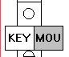

If you want to draw the circle by mouse then left click on “MOU” option. The process of drawing a circle is similar to the process of drawing line. Have an experience of it yourself.

* **Through keyboard**

If you want to draw the circle through keyboard then click on “KEY” then the program will show a place to for user to type in. At this time, you only need to type in your value for three parameters:

* a: The x-coordinate of circle center.
* b: The y-coordinate of circle center.
* r: The radius of circle.

When you are done with one parameter you may move to the next by press TAB or SPACEBAR or ENTER. You may use BACKSPACE to remove the value.

Have an experience of it yourself.

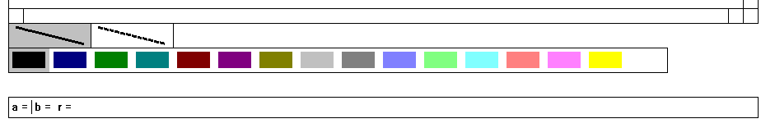

**Square drawing**

Square drawing is similar to line drawing.

**Color filling**

Left click the E:\Paint-8.pngbutton and then left click a point on drawing area, the program will automatically filling the color until it meets boundary.

**Character drawing**

Hover mouse over the ABC button then it will give you three options: A, B and C.

E:\Paint-8.png

Left click on one of the option to choose the character to draw. The process of character drawing is similar to line drawing.

**Scrollbar**

There are also vertical scrollbar and horizontal scrollbar that you may use when your drawing exceeds the viewable drawing area.